Kindergarten Supply List
How Many | What I need | Picture
2 | Composition Notebooks | 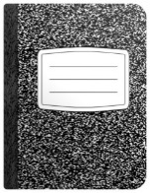
1 | Pencil Box | 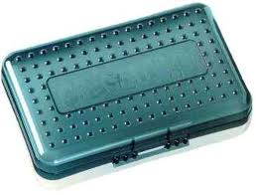
2 | 2 Pocket folders with 3 prongs | 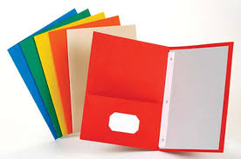
1 | Packages of pencils (10-12 count) | 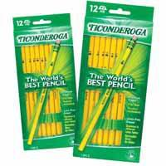
6 | Glue Sticks | 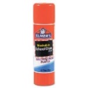
2 | Handwriting Tablets | 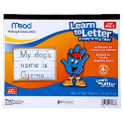
1 | Headphones | 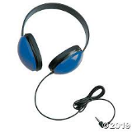
1 | Reusable Water Bottle or  Bottled Water  (The water fountains are turned off) | 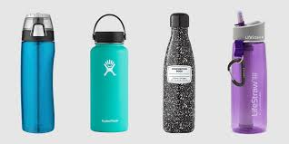
2 | Packages of skinny BLACK dry erase markers | 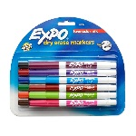
2 | Boxes of Crayons-box of 24 | 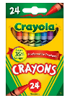
2 | Rolls of paper towels | 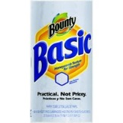
Please send donations | Disinfectant Wipes | 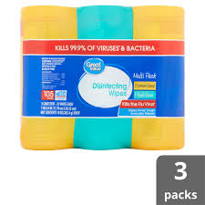
1 | Complete change of clothes (underwear, socks, pant, shirt) in a ZIPLOCK bag labeled with child’s name | 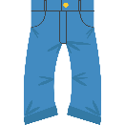

BOYS ONLY-1 box of Gallon size ZIPLOCK Bags
GIRLS ONLY-1 box of Quart size ZIPLOCK Bags

